

eSC - Energy Consumption Analysis

Forecasts and Suggestions for Potential Energy Usage
Project Report
IST 687 - Fall 2024
Date: 12/8/2024

Group - 2
Purtee Bhise, Neelam Gujar, Neha Shirodkar

Table of Contents:

1. Project Scope………………….……………………………………………………………… 3 2. Data Analysis & Merging ……….………………….……………..…………….…………… 3 3. Visualizations…………………………………………………………….….……………….. 6 4. Data Modeling………………….……………………………………….……………………...17
a. Time Series……………………………………………………………………….……17 b. ANOVA for Variable Choice…………………..……….……………………….……20 c. Random Forest…………………………………..…….……………………...………..22
e. Linear Regression……….……………………….……………………………………24
5. Forecasts & Future Peak Energy Demand.……………………….….………………………25 6. Shiny Application……….….…….…………………………………………….……………26 7. Suggestions to decrease Potential Energy Usage……….……..………………….…………28 8. Team Members - Work Log ………………………………………………………...……...…34

- Project Scope:
The main purpose of this project is to present the energy company eSC, with specific information regarding the consumption patterns of electricity among their customers. We therefore, focus on the effects of possible future temperature increases due to global warming. This would ensure that eSC is in an informed position to make appropriate decisions that deter overcrowding of their electrical grid during periods of peak demand especially in the month of July without having to build new energy production facilities.
- Data Analysis & Merging:
With the project scope defined, our next step was to strategize the data collection and organization process. The data provided by eSC fell into three distinct categories: static information for each house surveyed, energy usage data per house segmented by day and hour, and weather data for each county, also divided by day and hour.
Given that eSC's primary concern was the energy consumption in July i.e. the peak month for energy usage, we filtered both the energy and weather datasets to include only the July data. To facilitate a comprehensive analysis of total energy use per hour for each house, we created a new column that aggregated all individual energy metrics, resulting in a single total energy usage figure for each hour. This new column became the cornerstone for all subsequent predictive analyses.
We then faced the challenge of integrating these diverse datasets into a cohesive and meaningful structure. To achieve this, we implemented a two-step merging process in R. First, we cycled through each unique building ID (bldg_id) from the static house data to match and merge each house with its corresponding energy data. Next, we looped through each county ID (in.county) to align each house with the relevant weather data from its county.
The two loops in R were designed to ensure precision and efficiency in merging the datasets, resulting in a robust and comprehensive dataset ready for detailed analysis and modeling. Below is a visual representation of these merging loops in R:
Energy Merge Loop
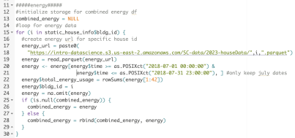
Weather Merge Loop
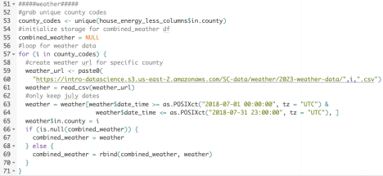

- Visualizations:
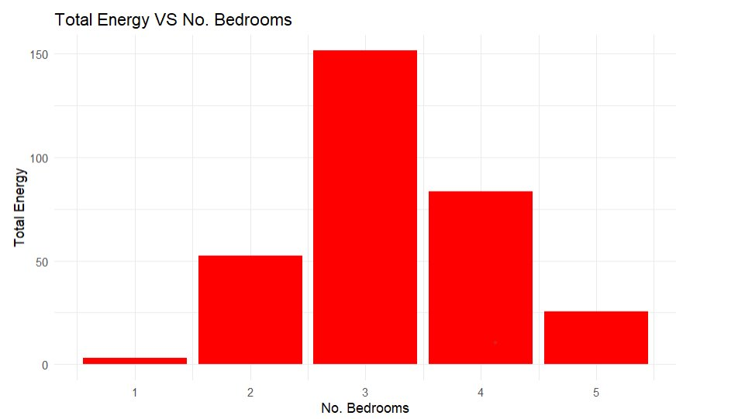
Fig. 1
The graph in Fig.1 illustrates the relationship between the number of bedrooms in a house and the total energy consumption. It is evident that houses with three bedrooms exhibit the highest energy usage. This observation may be attributed to several factors, including the higher occupancy rate of these rooms, which likely increases the demand for lighting, heating, and cooling. Additionally, the type of lighting used (e.g., daylight or warm lights) and the presence of various electrical appliances could also contribute to elevated energy consumption in three-bedroom homes. This data highlights the significance of considering household size and occupancy when analyzing energy usage patterns.
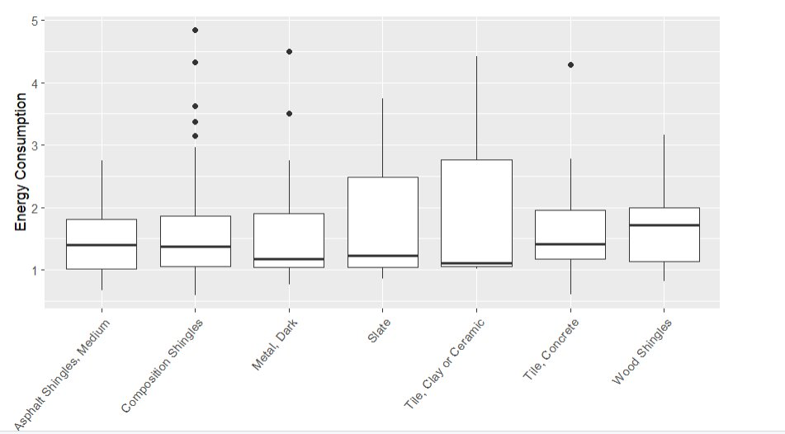
Fig.2
The graph in Fig.2 depicts the relationship between different types of roofing materials and energy consumption. The data reveals notable variations in energy usage based on the roofing material used. Specifically, homes with slate and tile (clay or ceramic) roofs exhibit higher median energy consumption compared to those with asphalt shingles, composition shingles, metal (dark), concrete tiles, and wood shingles. This disparity in energy consumption could be influenced by the thermal properties of the roofing materials, their ability to reflect or absorb heat, and their insulation capabilities. The presence of outliers, particularly in the categories of composition shingles and slate, further suggests that other factors, such as roof age, maintenance, and geographic location, may also play significant roles in determining energy efficiency. This analysis underscores the importance of selecting appropriate roofing materials to optimize energy consumption in residential buildings.
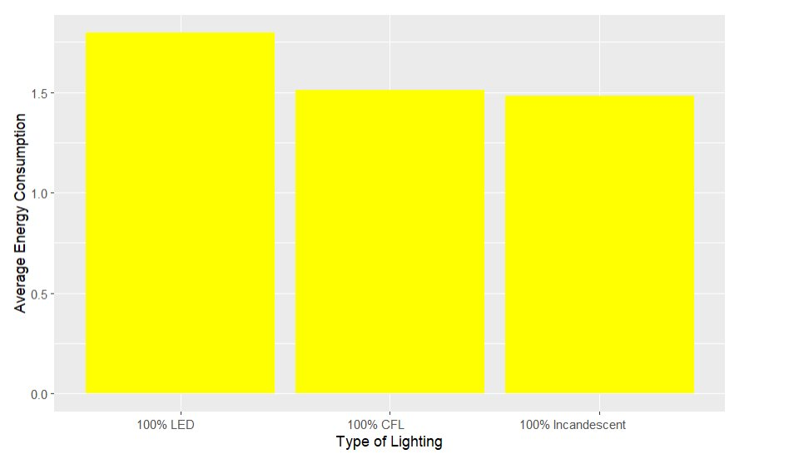
Fig.3
The graph in Fig.3 showcases the average energy consumption associated with different types of lighting: 100% LED, 100% CFL, and 100% incandescent. Interestingly, the data indicates that homes utilizing LED lighting exhibit the highest average energy consumption, followed by those using incandescent and CFL lighting. This counterintuitive result could be influenced by several factors, such as the number of lights used, the duration of usage, and the overall household energy consumption patterns. Despite LEDs being more energy-efficient on a per-bulb basis, their higher initial installation cost might correlate with higher overall energy usage in more affluent households that can afford extensive LED installations. This analysis highlights the complexity of energy consumption patterns and suggests that simply switching to energy-efficient lighting may not always lead to lower total energy usage without considering broader household behaviors and energy management practices.
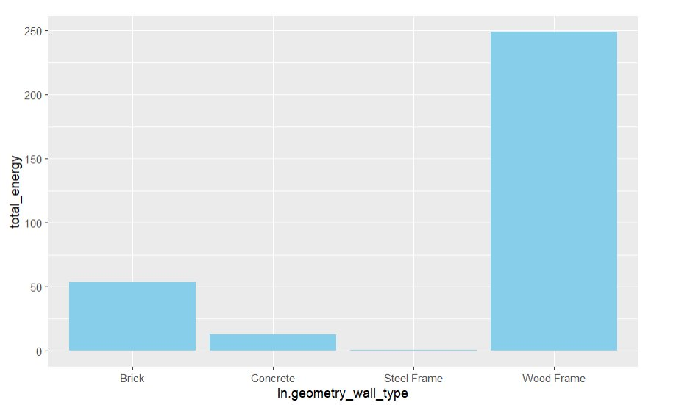
Fig.4
The graph in Fig.4 highlights how different wall types influence total energy consumption in homes. It shows that houses with wood frame walls use the most energy, followed by those with brick and concrete walls. On the other hand, homes with steel frame walls consume the least energy. This difference is likely due to the varying thermal properties and insulation effectiveness of these materials. Wood and brick, although popular for their aesthetic appeal and strength, may not insulate as well as steel, which is known for its excellent insulation and ability to minimize heat loss. This analysis emphasizes the importance of choosing the right wall materials to enhance energy efficiency and lower energy consumption in homes.
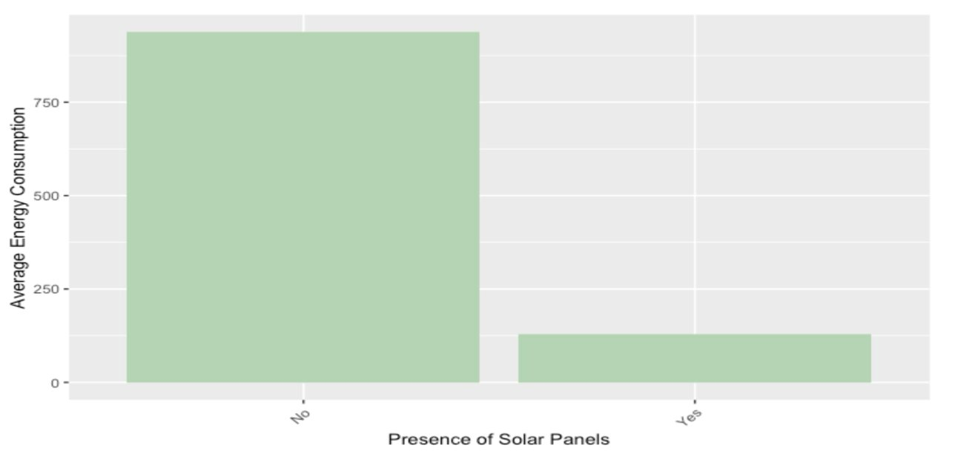
Fig.5
The graph in Fig.5 clearly illustrates a substantial reduction in energy consumption following the installation of solar panels, positioning it as a key solution to achieve our goal of reducing energy usage. The data reveals that homes without solar panels consume over 750 kWh, whereas those with solar panels installed consume less than 250 kWh. This stark contrast highlights the effectiveness of solar panels in significantly lowering energy consumption. The adoption of solar energy not only mitigates the demand on the electrical grid but also promotes sustainable energy practices. This insight underscores the importance of integrating solar technology in residential areas as a critical strategy for energy conservation.

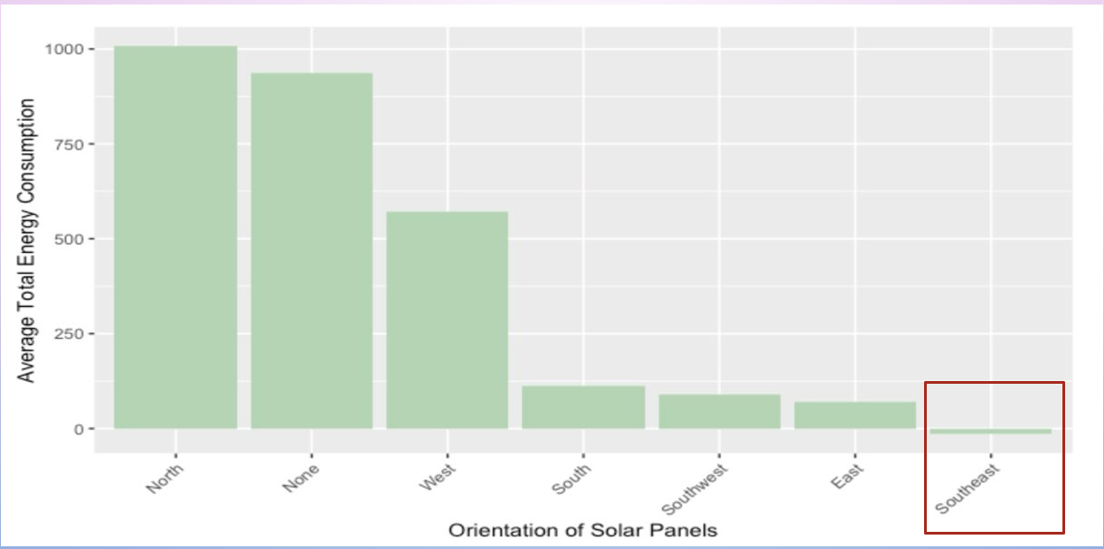
Fig. 6

The graph in Fig.6 reveals that solar panels oriented towards the Southeast demonstrate the highest efficiency, as evidenced by their lower average energy usage in July. This suggests that Southeast-facing panels can achieve the desired energy output with reduced consumption, likely due to optimal sun exposure during this period. This finding underscores the critical importance of directional orientation in the installation of solar panels to maximize their efficiency.
- Data Modeling:

- Random Forest:
Once we identified the key variables for our model, the next step was to aggregate the data by day. This involved summing the total energy consumption for each house at every hour and calculating the mean temperature for each house daily. With this prepared data, we turned to a modeling approach of Random Forest. This method is particularly valuable because it not only provides robust predictive power but also offers insights into the relative importance of each variable. By running the model, we were able to identify which features played the most significant role in the decision-making process. After aggregating the energy and temperature data by day and merging it with the static house information to incorporate the relevant variables, we split the data into 80% training and 20% testing sets. Using this split, we executed the random forest model, which helped us better understand the driving factors behind the energy consumption model.
- Random Forest Model Code:
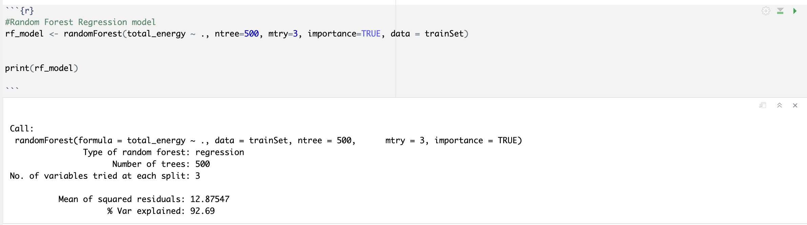

The last two lines of code use the model to predict on the test set, and from these predictions, we generated an RMSE of 3.6. This means that on average, we are only 3.6 kWh off the true
total energy used for a house on any given day. We also calculated the R² value manually using the following code.
- R² Random Forest Value:
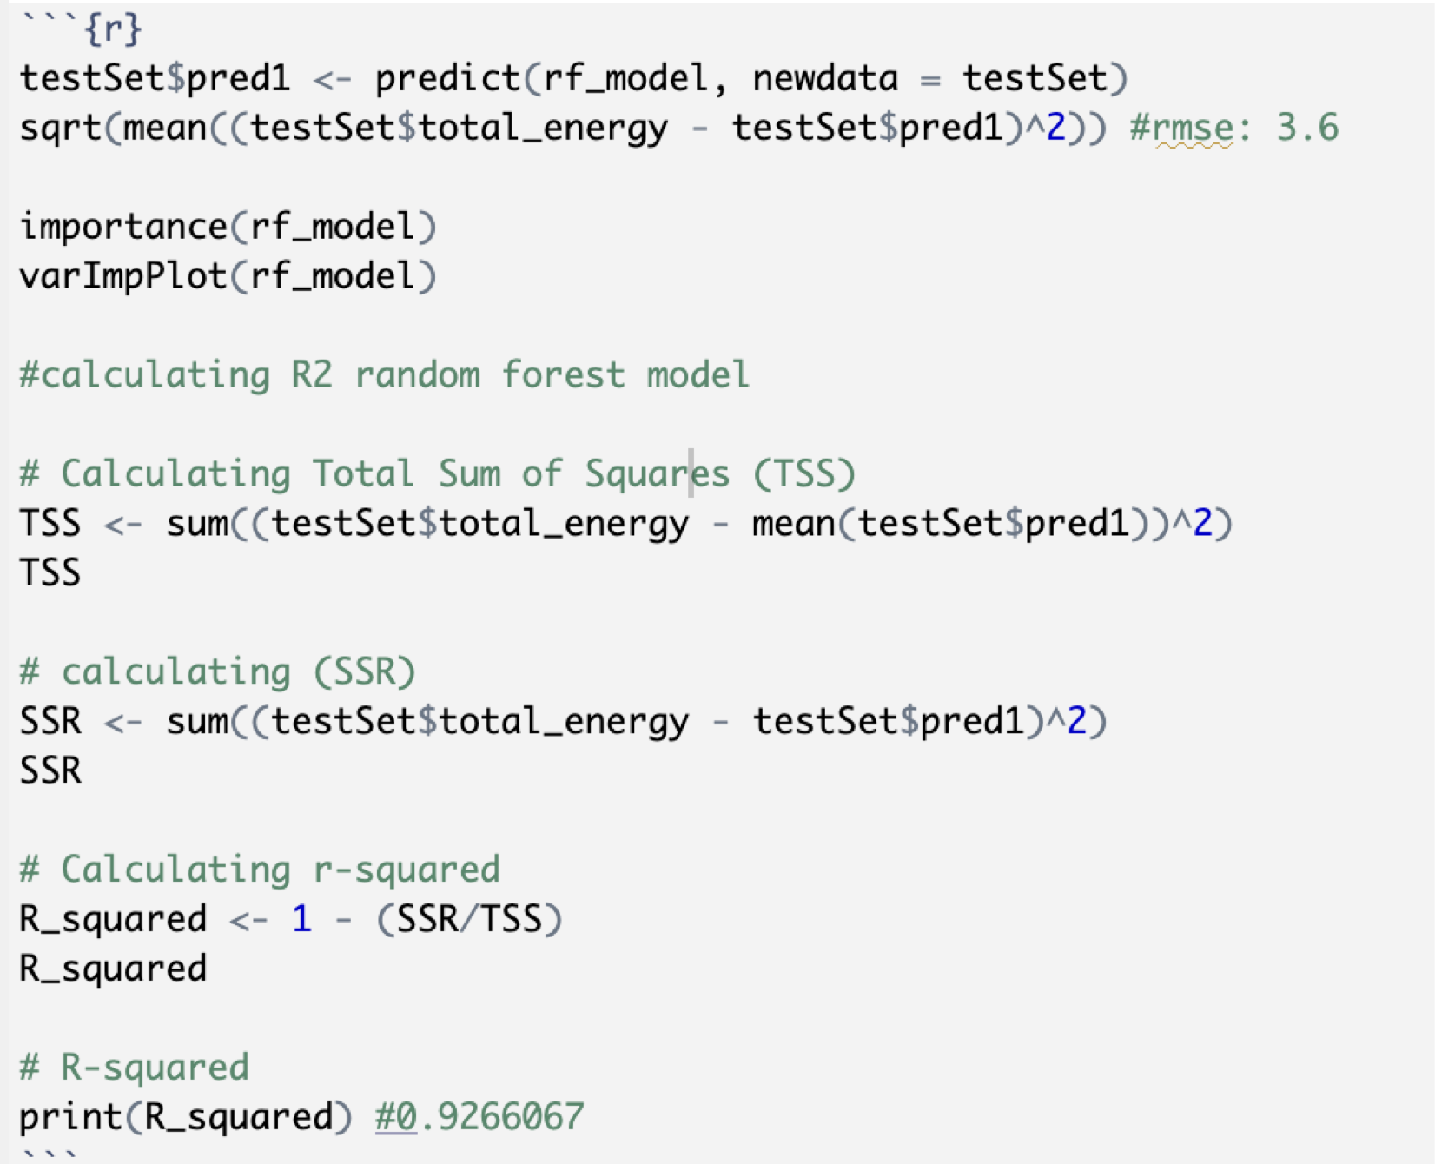

The R² value for our random forest model was an impressive 92.6%, indicating that we were able to explain 92.6% of the variation in energy consumption using temperature and the selected variables from the static house data. This high level of predictive accuracy prompted us to explore what the energy usage might look like in the coming year, assuming a 5°C temperature increase. We made predictions for next year’s data and visualized these predictions in a plot, comparing them with the historical energy consumption data to assess the potential impact of the temperature change.

- Random Forest Predictions Plot:
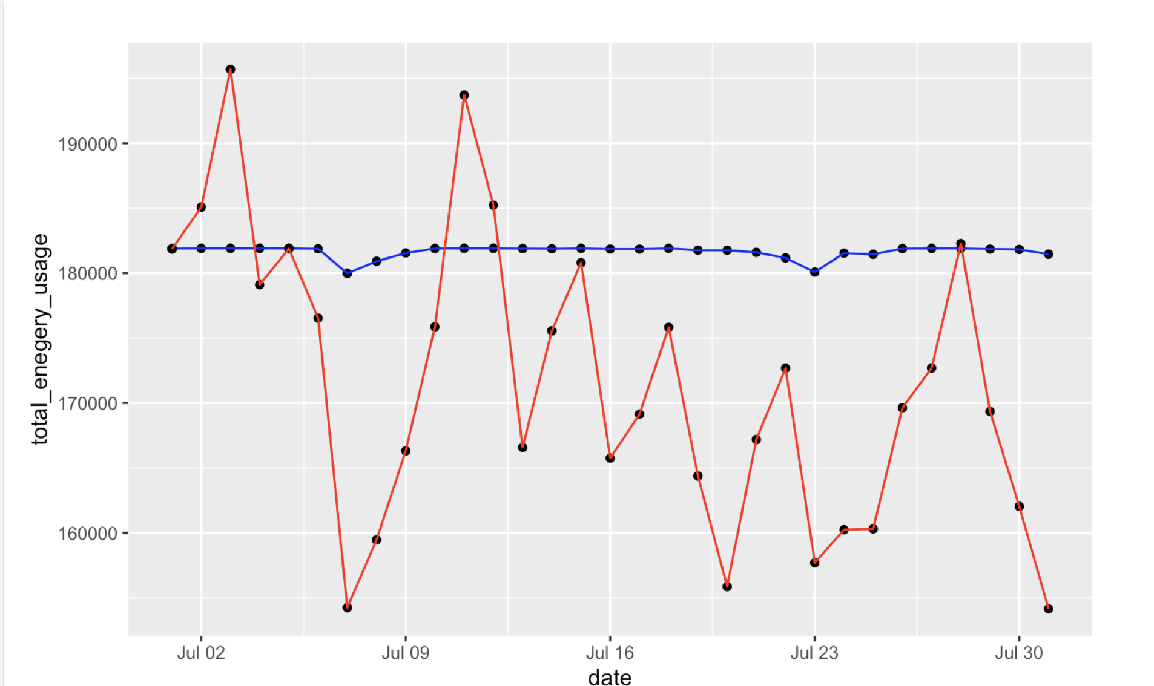Upon reviewing the plot, we noticed an anomaly, suggesting further exploration. Our research revealed that random forest models tend to struggle with extrapolation, meaning that when we input temperature values much higher than those seen during model training, the predictions lost their accuracy, despite the model’s impressive performance during training and testing. Recognizing this limitation, we decided to explore alternative models that would offer similar accuracy in the training phase but perform better when predicting future data. Therefore, we evaluated a variety of modeling approaches, including linear models and time series.

- Time Series:
At first, we hypothesized that a time series model would be the most suitable for our data, given its hourly structure spanning the entire month of July. However, we encountered a challenge: each house would require its own individual time series to properly sequence the data, which became impractical with over 5,000 houses. To overcome this, we decided to aggregate the data at the county level, creating a distinct time series for each county, capturing both temperature and energy data for each hour of July. Since weather data was consistent across all houses within a county, no further aggregation was needed for that variable. For energy, we calculated the sum of total energy usage across all houses in each county to form a county-wide energy metric. After ensuring the data was properly ordered within each county, we developed a loop that cycled through each county's code to generate time series models, using time and weather data to predict total energy consumption. Furthermore, within the loop, we utilized the model to forecast energy usage for the following year, factoring in the projected temperature increases. The core loop code for this process is shown below.
- Time Series Modeling Loop:
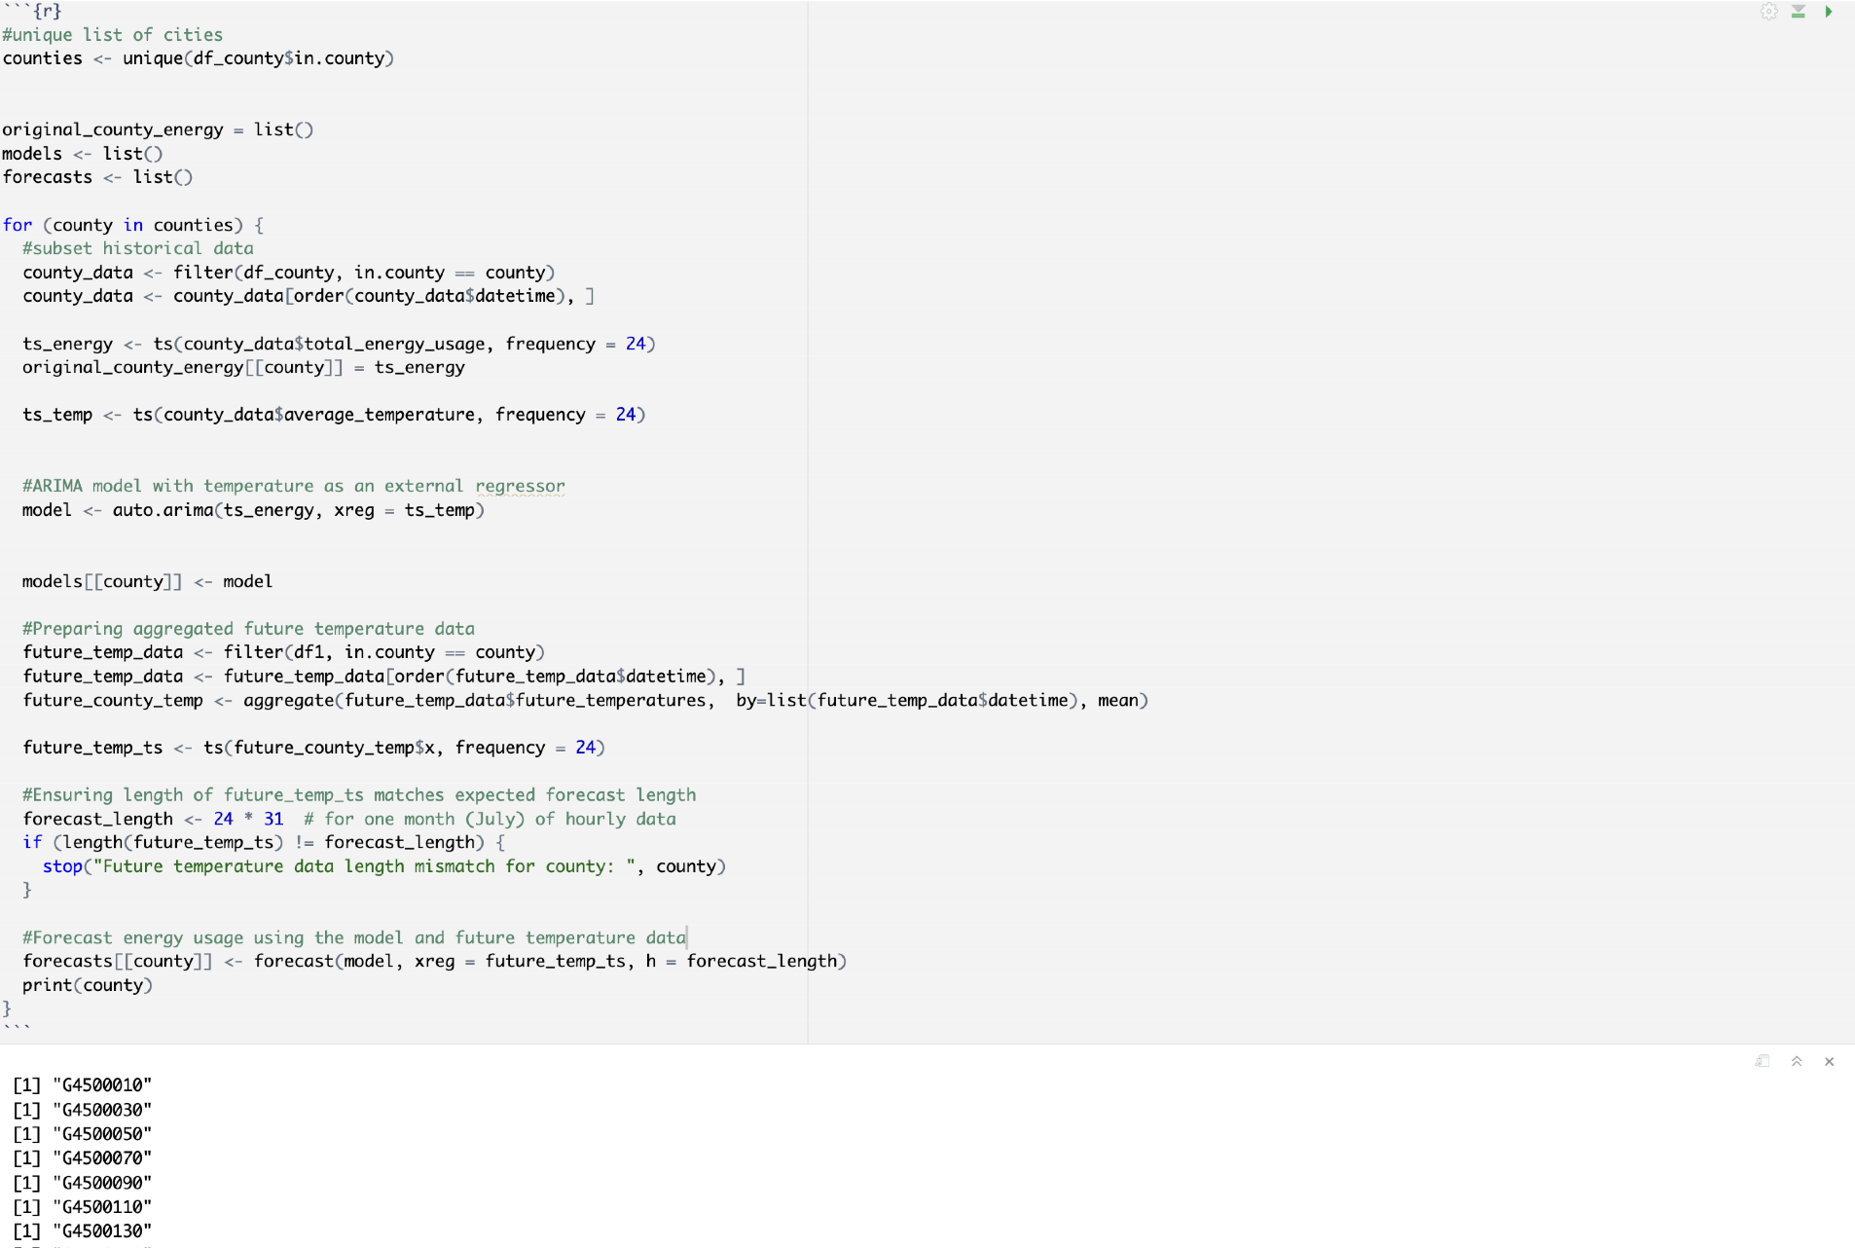

Now that we have both the model and the forecast results from the time series output, we can create a plot for each county that shows historical energy use compared to future predicted energy use. The plot below shows the time series output for the county G4500010.

- Time Series Plot of Historical vs Predicted Energy Use:
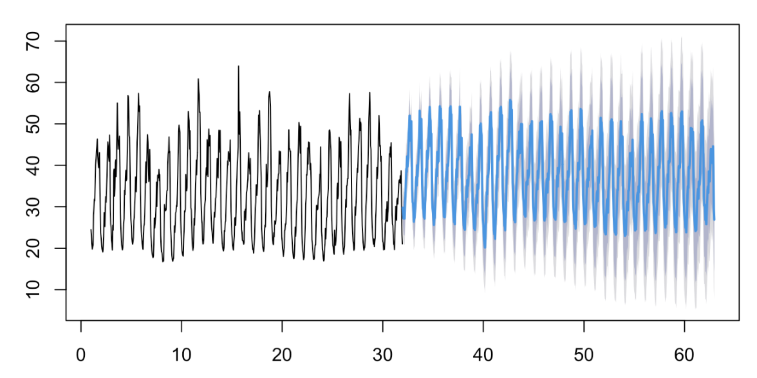 In the graph, the black line represents the actual energy consumption for 2018, while the blue line indicates the predicted energy use for 2019, with the light gray shading representing the confidence interval. Notably, the predictions for the following year are generally higher than the energy usage in 2018, which aligns with the anticipated rise in temperature. However, the relatively broad confidence intervals suggest that the model may not offer a high degree of accuracy.
While the predictions generated by the time series model were insightful and relevant, we ultimately decided not to proceed with it as our final model for one key reason: it did not allow for the inclusion of additional input variables beyond datetime and temperature. Time series models are inherently limited in the number of external regressors they can accommodate, and in this case, we had a substantial amount of valuable data from the static house dataset that we could not incorporate. Furthermore, since we aggregated the data at the county level, including house-specific information was simply not feasible. To overcome this limitation and identify the most significant house-level variables influencing energy consumption, we opted to perform Linear Regression testing as our next step.
- Linear Regression:
The final model that we chose for predicting our future energy usage was a Linear Model. We aggregated each house’s total energy consumption by day, averaged hourly temperature to get the daily temperature and merged the total energy consumption and temperature with the shortlisted house static data columns. We made a 80-20 train-test split and ran the following code:

Our linear model gave us an adjusted R-squared value of 85%. This means that 85% of the variation in total energy usage can be explained by our independent variables. The Root Mean Squared Error for our model was 5.15. This means that on average, our predictions are only 5.15 kWh off from the true daily energy usage. Below is the output from the model. Linear Regression Model Results
Since our linear regression model was accurate and simple but effective, we decided to use this model for our future energy usage predictions. Therefore, we created a new column in the dataset with all the mean temperatures increased by 5℃ and predicted on this data (keeping all static house columns the same) using the finalized linear regression model.
- Forecasts & Future Peak Energy Demand
Our energy usage predictions for the next year are plotted in the graph below using the red line, and the historic energy data is depicted by the blue line. Ultimately, we can see that the future predictions are much higher than the historical energy usage, which makes sense when considering the large increase in temperature that we accounted for.

- Model Predictions vs Past Energy Usage:
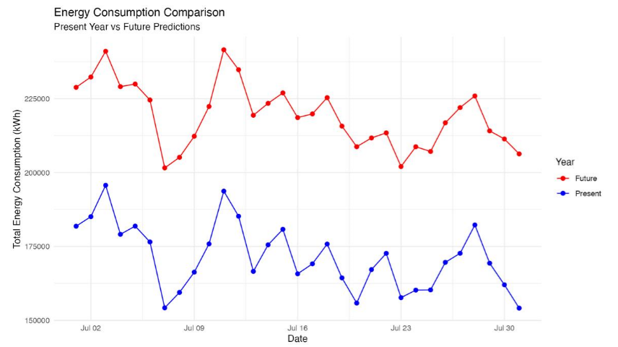
In conclusion, the required grid capacity for eSC to meet all energy demands next year is significantly higher than 225,000 kWh per day. While eSC should be capable of supporting slightly above this threshold, it is crucial to account for minor fluctuations in energy usage to ensure reliability and avoid potential shortfalls.

Shiny Application:
Below is the link to our Shiny webpage including few screenshots of the application.
Link to Shiny Application webpage: https://megkratzer.shinyapps.io/FinalProjectShiny/

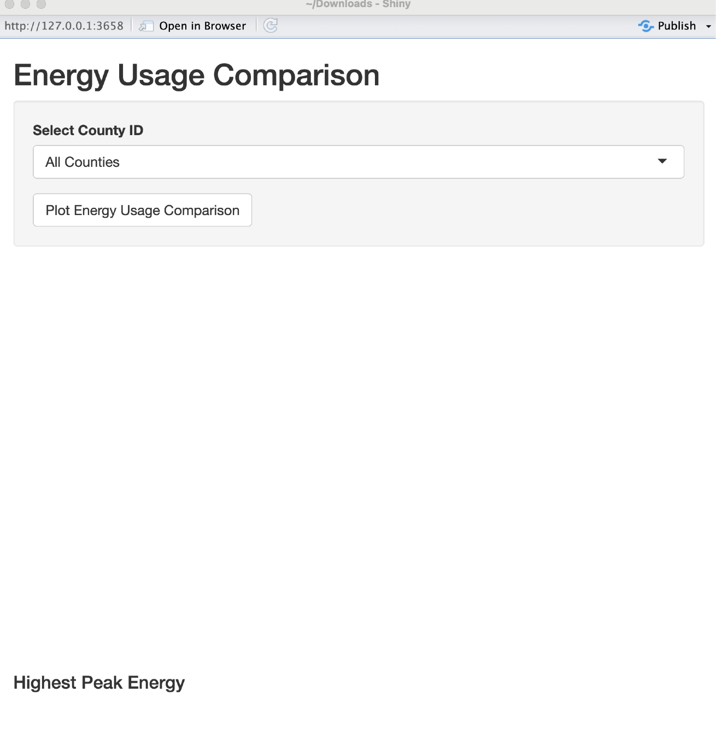

- Screenshots of the Shiny App:
The users can select any single county or all the counties to plot a line graph.
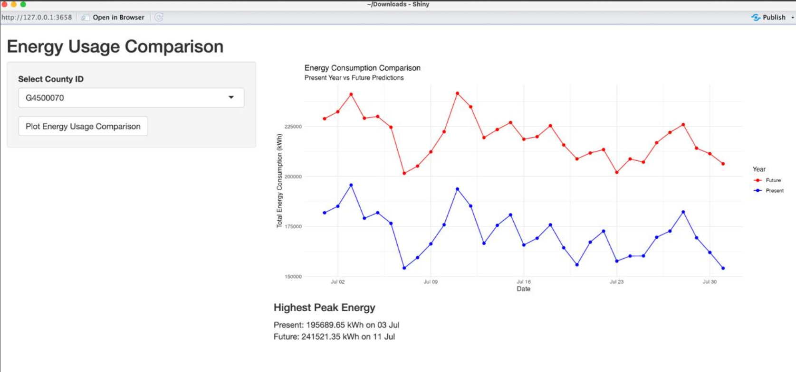
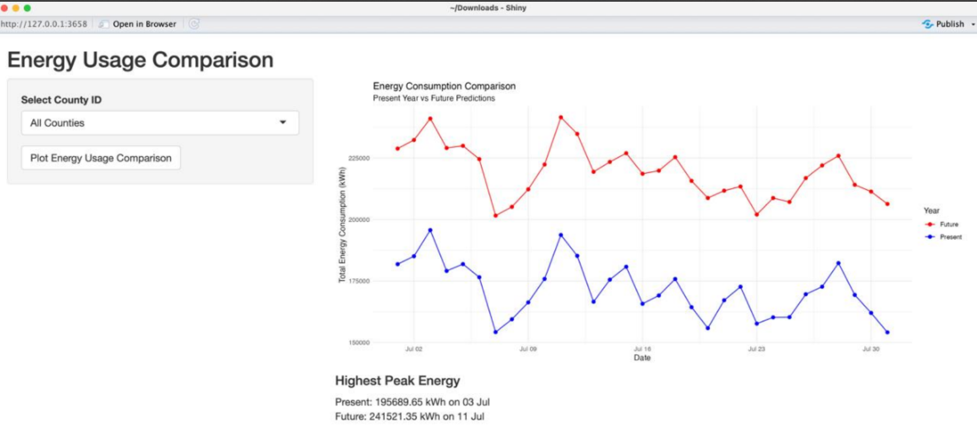
Upon selecting a county ID or All Counties option from the dropdown, a graph can be plotted. Referring to the above images, the blue line indicates the present energy usage i.e. in 2018 and the red line indicates the predicted energy usage in 2019. The text box below also gives us more details regarding highest peak energy usage for both present and future along with the exact date and the energy usage in kWh.
Thus, any individual county can be selected to plot data for analysis and find the daily maximum energy usage.
- Recommendations to eSC

- During our data exploration phase we discovered that one of the biggest factors that affected a house’s energy consumption was the presence of solar panels. The below bar graph depicts the average energy consumption in South Carolina for houses that have solar panels versus houses that don’t.


As evident from the data, the installation of solar panels significantly reduces energy consumption. We recommend that eSC encourage their customers to install solar panels in their homes to lower overall energy use. One effective approach could be offering discount to customers who provide proof of solar panel installation. This strategy is cost-effective in the long term, as it reduces the amount of energy eSC needs to supply, ultimately saving money. eSC can leverage these future savings to fund the rebates now. Additionally, a marketing campaign highlighting the financial and environmental benefits of solar panels would likely encourage more customers to adopt this technology. Additionally, forming a partnership with a solar panel provider would also streamline the process for customers, making it easier for them to find and install solar panels without having to search for options independently.

- Another important discovery regarding solar panels that we made is that the direction the solar panel is facing has an impact on the energy it produces.

We therefore advise eSC to recommend their customers to direct solar panels toward the Southeast to maximize energy production. This orientation likely benefits from optimal sunlight exposure. To achieve this, eSC can provide guidance to customers on the best direction for installing new solar panels and suggest reorienting existing panels when feasible. Informing customers about these recommendations will help them enhance their energy efficiency and maximize the benefits of their solar installations.
- A secondary recommendation that we would give to eSC is to incentivize their customers to switch their lighting to LED. The bar graph below depicts the average energy usage in South Carolina for each type of lighting. Evidently, LED lighting results in lower energy consumption.


We suggest that eSC encourage customers to switch to solar power and LED lighting by providing financial incentives. For instance, eSC could offer rebates and discounts for customers to make the switch. Governments often provide tax incentives to get citizens to adopt renewable energy solutions. eSC could educate its customers about available tax credits for solar installations. eSC could also provide customers with education materials like brochures that explain the benefits of switching to solar power and LED lighting. For instance, they could educate customers on the potential savings on energy bills in the long run.
- Team Members - Work Log:

Neelam:
- Explored datasets to derive variables for visualizations.
- Created visualizations for columns shortlisted as part of EDA.
- Worked on the UI of the Shiny app.
- Worked on Time Series & Random Forest modeling.
- Downloaded, cleaned, and merged the data using for loops.
- Worked on the final presentation.

Purtee:
- Explored datasets to derive variables for visualizations.
- Created visualizations for columns shortlisted as part of EDA.
- Worked on Time Series & Random Forest modeling.
- Developed Linear Models.
- Created a variety of graphs for comparison between different attributes.
- Worked on the final presentation and documentation.

Neha:
- Explored all datasets to determine which variables to use.
- Created the Shiny App.
- Worked on Linear Models.
- Plotted visualizations such as ggmaps and bar graphs as part of EDA.
- Created visualizations for columns shortlisted as part of EDA.
- Worked on the final presentation and documentation.

